**PRODUCT BACKLOG REFINEMENT-SPRINT 4**



**Date:5/4/2017**

Contents

I. BACKLOG ESTIMATE EVIDENCES 3

1. VIEW SITE FOUNDATION 3

2. VIEW FAQS 4

3. VIEW CONTACT PAGE 4

4. VIEW OTHER USER PROFILE 5

5. SEARCHING SKILLS 5

6. REQUEST LOG 5

7. REQUEST SWAP 5

8. EXCHANGE SWAP DETAIL 6

# BACKLOG ESTIMATE EVIDENCES

## VIEW SITE FOUNDATION

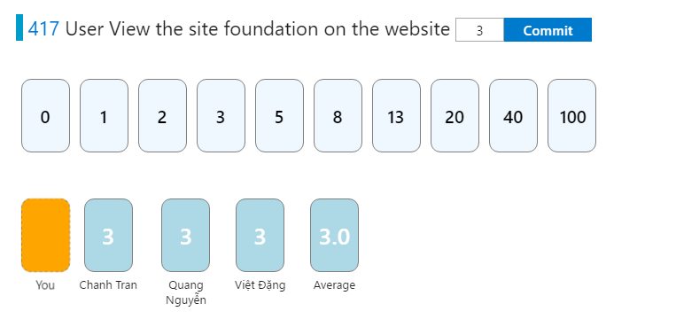

## VIEW FAQS

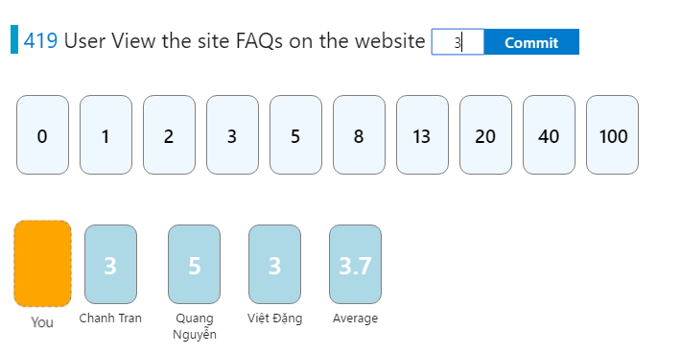

## VIEW CONTACT PAGE

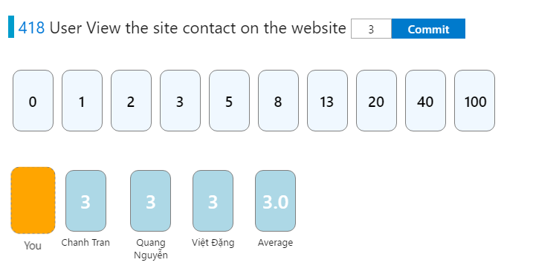

## VIEW OTHER USER PROFILE

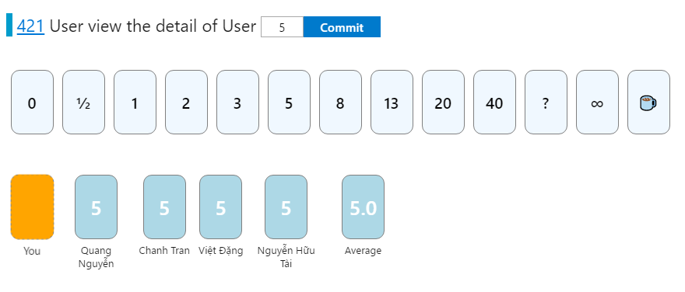

## SEARCHING SKILLS



## REQUEST LOG

C:\Users\Windows 10 TIMT\Desktop\Sprintbacklogrefinement1-2\Viewrequestlog.PNG

## REQUEST SWAP

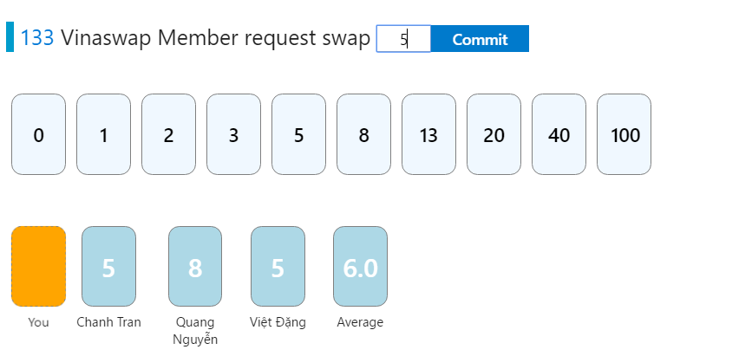

## EXCHANGE SWAP DETAIL

